SHOPPING: AT THE SUPERMARKET AND THE GROCERY LIST

DIALOGUE 1
1.What is the customer buying?
CHEESE , BEEF, HAM
2.Write the QUANTITIES (pound, kg) for each food that the customer buys.
QUARTER-POUND ¼ LB
SOME BEEF
10 SLICES OF HAM
3.Write one WH-question

4.Write one sentence in the dialogue used to make a request (ask for something)

DIALOGUE 2

1.What are the two people talking about?
FOOD FOR DINNER/ MAKING A RECIPE/ COOKING
GROCERY SHOPPING LIST

2.what foods do they talk about?

3.What recipe do you think they are making?
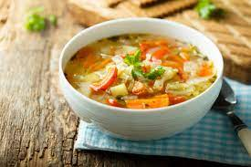SOUP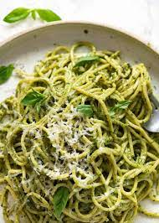PASTA PESTO
OMELETTE AND SALAD

