EMPLOYMENT THEME, COVER LETTER, FINAL TASK

Think of a job you would like to have , or have or had, in Canada or in your home country.

Think about the skills you need for that job and the skills you have. Think about your experience, hard skills (education) and soft skills.

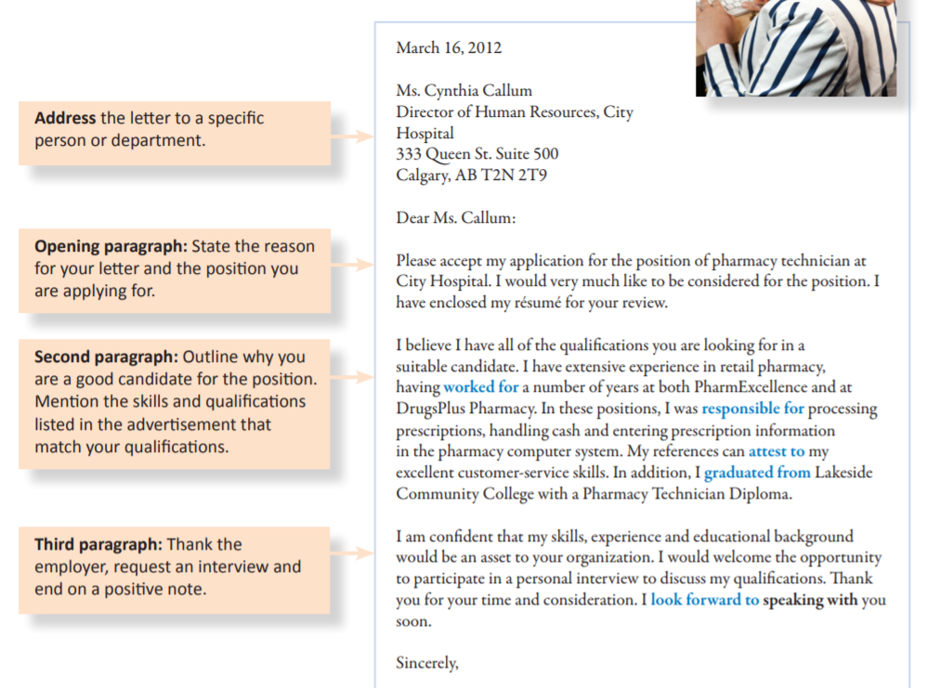Put everything together and write a cover letter. Use the sample provided that you keep the parts that are “standard” only. Add your information.